1. Convert the following ER diagram to a Relational model.

Student

Tutor

Course

Subject

ON

Tutors

Name

TCode

Name

Extn

Scode

Title

Date

Grade

ID

Code

Director

N

N

N

1

M

1

Results

Student

|  |  |  |  |
| --- | --- | --- | --- |
| ID | Name | Code | TCode |

|  |  |
| --- | --- |
| Code | Director |

Course

Tutor

|  |  |  |
| --- | --- | --- |
| TCode | Name | Extn |

Results

|  |  |  |  |
| --- | --- | --- | --- |
| ID | Grade | Date | SCode |

Subject

|  |  |
| --- | --- |
| Title | SCode |

StudentSubject

|  |  |
| --- | --- |
| ID | SCode |

2. Refer to the ER diagram given below of a Bank database, Map the ER to a relational schema indicating all the primary keys and foreign keys.

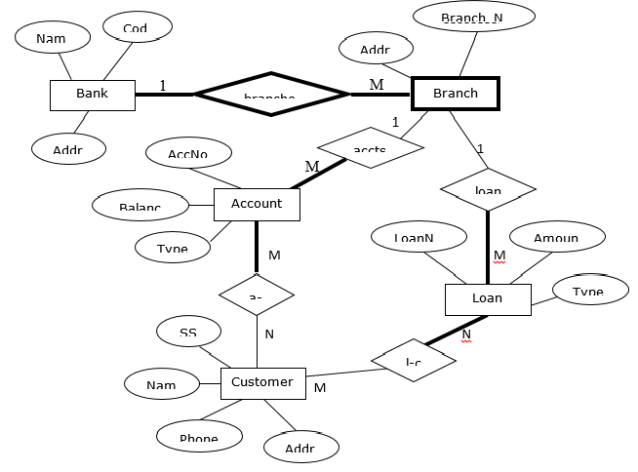

Bank

|  |  |  |
| --- | --- | --- |
| Cod | Name | Address |

Branch

|  |  |  |
| --- | --- | --- |
| Branch_N | cod | Address |

Account

|  |  |  |  |  |
| --- | --- | --- | --- | --- |
| AccNo | Balance | Type | cod | Branch_N |

Customer

|  |  |  |  |  |
| --- | --- | --- | --- | --- |
| C_ID | SS | Name | Phone | Address |

AccountCustomer

|  |  |
| --- | --- |
| AccNo | C_ID |

Loan

|  |  |  |  |
| --- | --- | --- | --- |
| LoanN | Amount | Type | Branch_N |

LoanCustomer

|  |  |
| --- | --- |
| C od | LoanN |

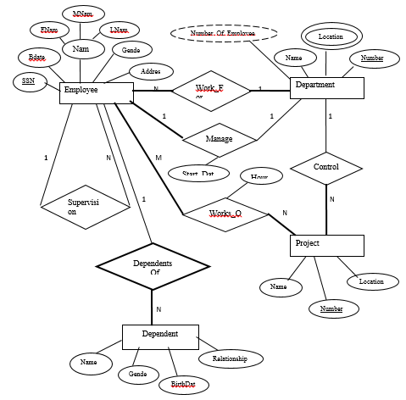3. Map the company ER given below to a relational database schema.

Employee

|  |  |  |  |  |  |  |
| --- | --- | --- | --- | --- | --- | --- |
| SSN | Bdate | Gender | Address | dnumberm | dnumberw | startdate |

EmployeeName

|  |  |  |  |
| --- | --- | --- | --- |
| SSN | Fname | Mname | Lname |

Supervisor

|  |
| --- |
| SSN |

Department

|  |  |
| --- | --- |
| Name | Number |

DepartmentLocation

|  |  |
| --- | --- |
| Number | Location |

Project

|  |  |  |  |  |
| --- | --- | --- | --- | --- |
| Number | Name | Location | DNumber | SSN |

Works_O

|  |  |  |
| --- | --- | --- |
| SSN | Hours | Number |

EmployeeProject

|  |  |
| --- | --- |
| SSN | Number |